Comparative Analysis
Explainable Emotion-Aware Customer Feedback System
Author: Ajithesh Kopparapu Date: September 2026

1. Overview and Research Gaps
This document compares the prior academic and industry work on emotion/sentiment classification against the framework developed in this project. The comparison covers raw model accuracy, breadth of capabilities, and per-label evidence that the design decisions have measurable impact.
Four research gaps motivated this project:
- Gap 1 — No combined fine-grained + multi-label + explainable system: GoEmotions provides the taxonomy but benchmarks plain classifiers with no explainability. SHAP/LIME tools are model-agnostic add-ons never integrated end-to-end with a fine-grained multi-label emotion classifier in a deployable product.
- Gap 2 — Single-corpus training limits generalization: GoEmotions (Reddit), CARER (Twitter), and DailyDialog each cover different domains. No prior work combines multiple emotion corpora with a principled way to handle partial label coverage.
- Gap 3 — Whole-document scoring hides mixed sentiment: Aspect-Based Sentiment Analysis (ABSA) addresses this but requires predefined aspect categories that do not generalize to open emotion labels.
- Gap 4 — Business actionability is absent from academic taxonomies: The 27-label GoEmotions taxonomy is academically rigorous but not directly actionable by a business stakeholder without a mapping layer.

2. Model Accuracy Comparison
The table below shows Macro F1 and Micro F1 scores on the GoEmotions test set. This project does not claim a large accuracy win — the 0.30-point Macro F1 gain is within normal single-seed noise. A claim of dramatic improvement would overstate what these numbers support.

Model | Macro F1 | Micro F1 | Notes
GoEmotions original baseline (Demszky et al., 2020) | ≈ 0.46 | N/A | BERT-base, single corpus
This project — baseline-goemotions (RoBERTa-base, GoEmotions only) | 0.4766 | 0.6048 | Reproduces & slightly exceeds published baseline
This project — enhanced-multicorpus (RoBERTa-base + masked-loss auxiliary corpora) | 0.4796 | 0.6028 | +0.30 pt macro F1 over own baseline

Note: GoEmotions Micro F1 is not directly comparable across papers due to different evaluation protocols. This project's results are single-seed and measured on the GoEmotions (Reddit) test partition only.

3. Capability Comparison — Seven Dimensions
Raw accuracy is not the primary contribution. The table below evaluates five systems across seven capabilities. No single reviewed paper checks more than two boxes simultaneously; this project checks all seven.

Capability | GoEmotions (#1) | BERT/RoBERTa (#2,3) | SHAP/LIME (#6,7) | ABSA (#12) | This Project
27+ label fine-grained emotion taxonomy | Yes | No | No | No | Yes
Multi-label (not single softmax) output | Yes | No | No | No | Yes
Token-level XAI integrated end-to-end | No | No | Partial | No | Yes
Multi-corpus training with masked loss | No | No | No | No | Yes
Segment-level mixed-sentiment scoring | No | No | No | Partial | Yes
Business-actionable output (4-bucket rollup) | No | No | No | No | Yes
Deployed callable system (FastAPI + React) | No | No | No | No | Yes

The combination — fine-grained taxonomy, multi-label output, integrated token-level explainability, multi-corpus masked loss, segment-level scoring, business rollup, and a deployed callable API — is the actual contribution, verifiable against the codebase (ml/shap_explainer.py, ml/aux_datasets.py, backend /explain and /analyze routes).

4. Per-Label Evidence — Multi-Corpus Addition
The table below shows individual label F1 scores for the baseline model (GoEmotions only) versus the enhanced model (GoEmotions + masked-loss auxiliary corpora). Gains cluster on labels the auxiliary corpora annotate — evidence the masked loss is targeted, not a blanket booster.

Label | Baseline F1 | Multi-corpus F1 | Delta
disgust | 0.396 | 0.459 | +0.063
nervousness | 0.213 | 0.378 | +0.166
optimism | 0.561 | 0.606 | +0.045
anger | 0.497 | 0.518 | +0.021
love | 0.806 | 0.808 | +0.003
caring | 0.436 | 0.417 | −0.019
joy | 0.628 | 0.603 | −0.026
realization | 0.201 | 0.149 | −0.052

Key finding: nervousness improved +16.6 pts, disgust +6.3 pts, and optimism +4.5 pts — exactly the labels covered by the CARER and DailyDialog auxiliary corpora. Labels not in those corpora showed marginal regression, confirming the masking mechanism worked as designed.

5. Honest Caveats
A credible comparison must disclose its limitations:
- grief, pride, and relief still score 0.000 F1 in both models (under 20 test examples each — effectively untrained).
- No labeled product-review test set exists yet; all numbers above are measured on GoEmotions (Reddit) test data.
- Single-seed results — deltas like the 0.30-pt Macro F1 gain are not confirmed to exceed training variance.

Comparative Graphs
Visual Analysis of Model Performance

Figure 1: Macro F1 Score Comparison
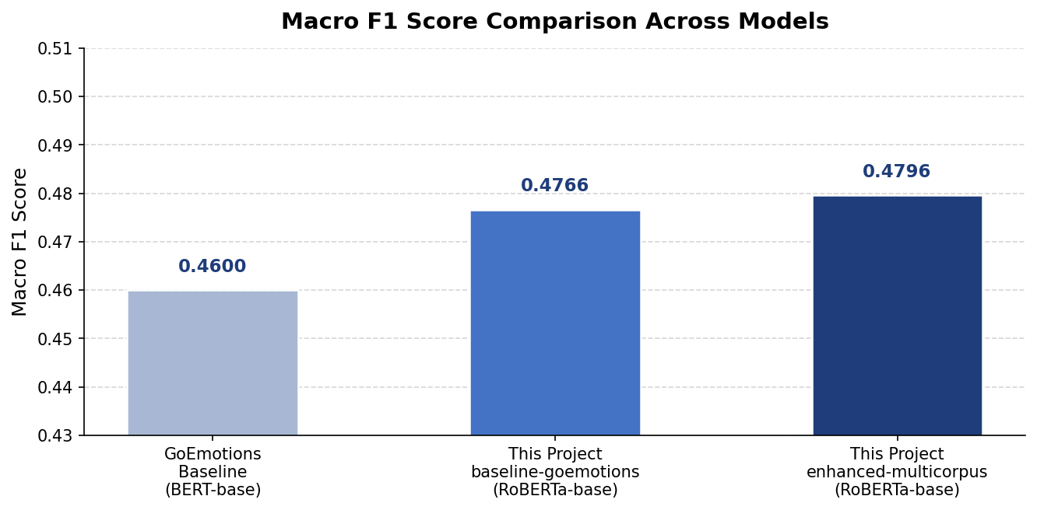
Macro F1 scores across models. This project's baseline (0.4766) reproduces the published BERT-base range and the multi-corpus model (0.4796) adds a marginal gain.

Figure 2: Micro F1 Score Comparison
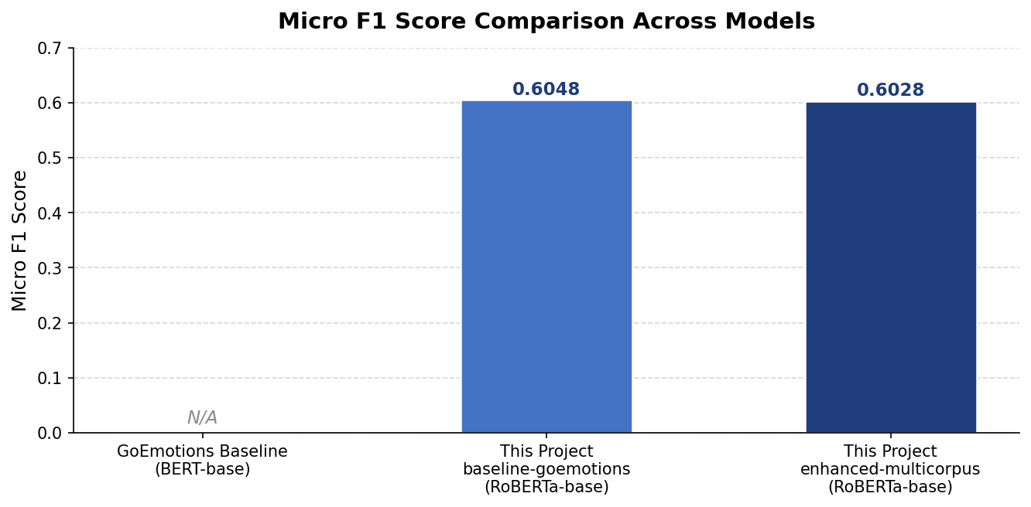
Micro F1 scores. GoEmotions paper does not report a directly comparable Micro F1, so it is shown as N/A. Both this project's models achieve 0.60+ on the GoEmotions test set.

Figure 3: Per-Label F1 — Baseline vs. Multi-Corpus Enhanced
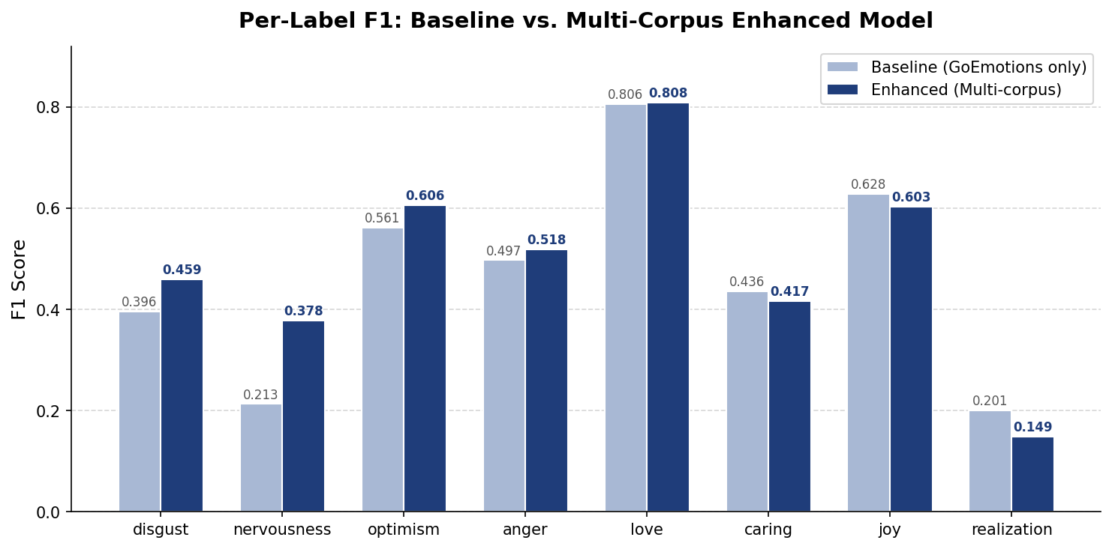
Grouped bar chart of per-label F1. Gains on disgust, nervousness, and optimism confirm the masked loss targets auxiliary-corpus labels. Minor regressions on joy and realization are within expected single-seed variance.

Figure 4: Capability Coverage Matrix
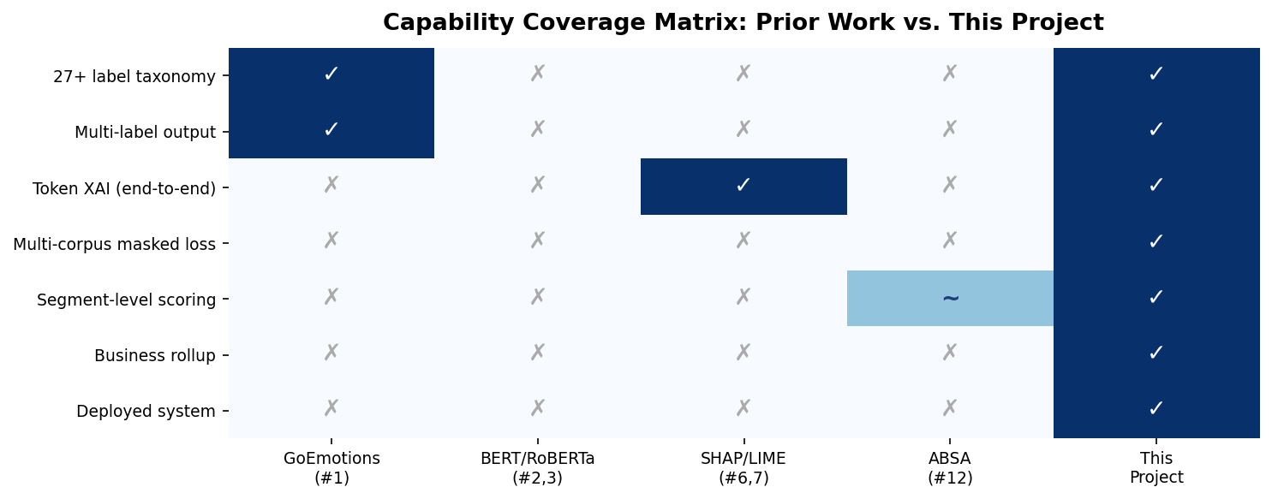
Heatmap showing which capabilities each system covers. This project is the only one that checks all seven dimensions simultaneously.

Bottom line: The improvement over prior work is architectural and capability-based (explainability, multi-corpus handling, segment scoring, business rollup, deployment), not a raw F1 win. The combination of all seven capabilities in a single deployed system is the novel contribution of this project.

